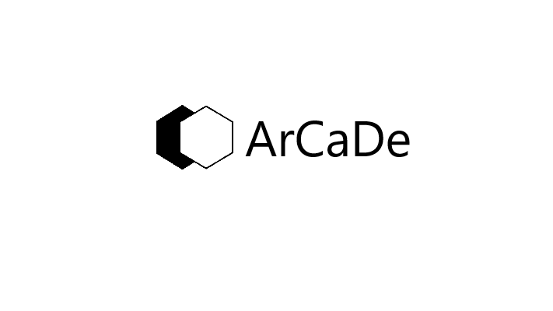

™

A MaN’s ArCaDe Music Subscription

**Music Harbor**

**Pay less and get more**

Claim all the songs you could ever imagine ranging from your childhoods rhythms to the latest charts dominating music the moment they get released, also includes access to all religious music from your favourite publishers from your DVD’s and also watch their performances, behind the scenes and music videos.

   

You are part of this Man’s arcade exclusive members only discount.

For only **₦800** a month (More than 10% and above off forever).

To make it easier for you, your payment can be done with airtime, Cash, PayPal or Transfer is accepted.

To start saving more than **₦1200** yearly and eventually startearning a guaranteed yearly income from us Contact us at [Musthyds@gmail.com](mailto:Musthyds@gmail.com) or whatsapp 08087113039 to Learn more.

**Apple music**: Unlimited number of songs, Create, publish and share Playlists, Get early access to new music, Easily download music videos, Know what music your friends are listening to, Explore the Thousands of playlists created just for you every week, Know what music is trending in different parts of the world, Get exclusive radio Stations, interviews and playlists from your favourite artists. Works with multiple devices.

**Music Harbour**: Track new releases of both songs and music videos according to date, Get informed about all the nearby concerts and performances dates. Listen to the new releases through Apple music.

**Genius:** Watch exclusive interviews with your favourite artists, Get lists of unreleased music and their lyrics, Get news reports related to artists, Read more into the explanations of lyrics line by line, share lyrics with your friends. Its Streaming works via Apple music.

**Shazam**: Identify music playing near you, Get the corresponding lyrics to the tracks identified, Store and listen to the identified music with Apple music, know global shazams.

**What exactly are you paying for ?**

**Arcade music Duo**

Register for music duo to secure music library from apple music.

We would provide a replica of all the songs that were in your apple music library and all your playlists as well.

Refer 5 people to sign up for an arcade music subscription and music duo for up to 12 months registration ad-on to get it for free for the next 10 years.

Types of music Duo

**Registration ad-on**

* Add the payment to your monthly fees
* Payment of 15% of the money payed
* It takes 7 days to retrieve all the lost music
* Comes with complementary 8GB memory card after 15 years of use

**Registration pay-on**

* Pay a sum of money on exit
* Pay N250 for month of use
* Takes 15 days to recover
* Nonmembers pay N30k for it

5 Musicians pictures their number of songs here as of 2020, number of unreleased songs, music video release date, Concert date and location,

Famous people that use apple music

QR code in Reciept shows

* What your password is
* Your email
* A Digital Version of the form

Registration Form



Scan for Password

**arcadeuserA500456@gmail.com**

QR code attached (Y/N)

First name:

Last name:

Date of Birth:

Nationality:

Country(ies) of residence:

City of residence:

Signature:

Referral code:

Phone number: + ( )

Your User ID is

To Request refferal code contact us at: [Musthyds@gmail.com](mailto:Musthyds@gmail.com), we would get back to you between 5 to 30 business days.

Registration Form

First name: Richard

Last name: Wopara

Date of Birth: 27/12/2004

Nationality: Nigerian

Country(ies) of residence: Nigeria, Canada

City of residence: Port-Harcourt

Signature:

Referral code:

Phone number: +2 3 4 (8 0 8 7 1 1 3 0 3 9 )

Your User ID is

To Request refferal code contact us at: [Musthyds@gmail.com](mailto:Musthyds@gmail.com) we would get back to you between 5 to 30 business days.

Get Mans arcade User ID : eg, arcadeuserA500456

Scan for Password



**arcadeuserA14@gmail.com**

F1Richard



QR code Attached

(Y/N)

MaN’s ArCaDe Reciept

Users Name: ……………….

User ID: …………………

Platform: Apple music Premium

Amount: ₦799 only

(₦100 off for 2 years per active invite)

Transaction method: ……………….

Date: …… …… ……., time: …… …… ……

Next billing date: …… …… …... (monthly)

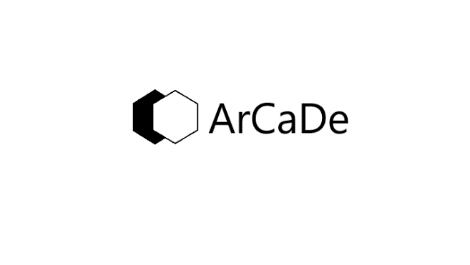

**Money online transfer can be made with,**

**“6151411035”**

**Fidelity bank,**

**Richard**

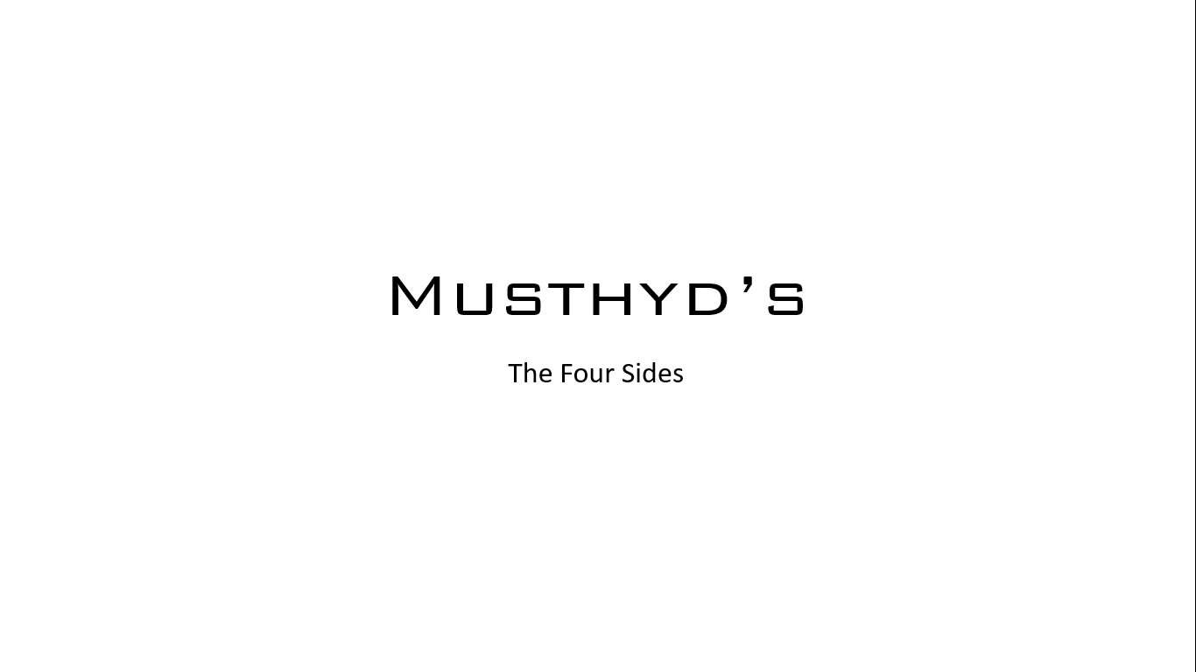

MaN’s ArCaDe Reciept

Users Name: Jack Cook

User ID: arcadeuser2@gmail.com

Platform: Apple music Premium

Amount: ₦500 only (on Discount)

(₦100 off for 2 years per active invite)

Transaction method: PayPal transfer

Date: Dec 19th, 10:25am (Today)

Next billing date: Jan 19th (monthly)



MaN’s ArCaDe Reciept

Users Name:

User ID: arcadeuser3@gmail.com

Platform: Apple music Premium

Amount: $8 (USD) only

($2 (USD) off for 2 years per active invite)

Transaction method: Bank transfer

Date: Dec 19th, 10:25am (Today)

Next billing date: Jan 19th (monthly)



MaN’s ArCaDe Reciept

Users Name:

User ID: arcadeuser4@gmail.com

Platform: Apple music Premium

Amount: $8 (CAD) only

($2 (CAD) off for 2 years per active invite)

Transaction method: PayPal

Date: Dec 19th, 10:25am (Today)

Next billing date: Jan 19th (monthly)



MaN’s ArCaDe Reciept

Users Name:

User ID: arcadeuser5@gmail.com

Platform: Apple music Premium

Amount: £8 only

(£2 off for 2 years per active invite)

Transaction method: Bank transfer

Date: Dec 19th, 10:25am (Today)

Next billing date: Jan 19th (monthly)



MaN’s ArCaDe Reciept

Users Name:

User ID: arcadeuser6@gmail.com

Platform: Apple music Premium

Amount: €8 only

(€ 2 off for 2 years per active invite)

Transaction method: Cash App

Date: Dec 19th, 10:25am (Today)

Next billing date: Jan 19th (monthly)

